Ask Open Eventz: Grounded Q&A Spec
Nov 6, 2026 · @SK

Problem and opportunity
Ask Open Eventz lets a parent type a question in plain language and get an answer drawn only from the Open Eventz catalog, with a link to every event it mentions. Today parents find events by browsing lists and filters. A question like "free things for a 4-year-old this Saturday in Plano" means crossing date, city, cost, and age filters by hand, and filters can't express "rainy day", "near the library", or "my kid loves trains".
The catalog already holds the facts parents decide on (cost, age suitability, registration, drop-off) from four civic sources, refreshed nightly. A grounded Q&A layer turns that catalog into answers without letting the model invent events, times, or prices.
For the portfolio, this is retrieval-augmented generation over trusted content I own end to end, measured with a standard evaluation framework (DeepEval) alongside the existing hand-labeled golden set.

Goals, non-goals, and success metrics
The goal is a correct, cited answer or an honest "I couldn't find that". A fluent answer that might be wrong is not a goal. Quality gates come first because the site has no users yet; the adoption metrics are defined now and read after launch.
Goals
- Answer catalog questions using only retrieved event records, citing each event used
- Refuse when nothing in the catalog matches, instead of guessing
- Never state a price, age range, date, or drop-off rule that the event record doesn't hold
Non-goals (v1)
- Chat memory across sessions, accounts, or personalization
- Booking, registration, or calendar writes
- Questions outside the catalog (weather, directions, parenting advice)
Success metrics
Metric | Type | Target | When
Faithfulness (DeepEval) | Ship gate | ≥ 0.90 on the eval set | Every change, in CI
Mislabeled free or wrong age in an answer | Ship gate | 0 cases | Every change, in CI
Correct refusal on no-match questions | Ship gate | 100% of no-match cases | Every change, in CI
Contextual recall (DeepEval) | Ship gate | ≥ 0.85 | Every change, in CI
Answer relevancy (DeepEval) | Quality | ≥ 0.85 | Every change, in CI
Questions ending in an intent action (event click, map, calendar) | Adoption, feeds North Star | Baseline, then set | 4 weeks after launch
Model cost per answer | Economics | Under the existing spend ceiling | Daily dashboard
Targets are starting points to confirm against the first eval run, then locked before the feature is measured, the same way the classifier ship gate was.

User experience
One search box above the event list, labeled "Ask about events", with three example questions underneath to show what works.
- The parent types a question, for example "free indoor things for a 4-year-old this Saturday in Plano".
- The answer appears in two to four sentences, followed by up to five event cards from the catalog. Every event named in the text links to its card.
- Each card shows the same fields as the list view (date, time, city, cost, age, registration, drop-off) and the existing confidence label when a value was inferred, for example "Family suitability estimated from event description".
- If nothing matches, the answer says so in one line and offers the closest filter view ("No free events for that age on Saturday. See all Saturday events in Plano").
- A small line under every answer: "Answers come only from events listed on Open Eventz. Check details with the venue."
Copy rules: no invented enthusiasm, no events that aren't on a card, and no answer to questions outside events (those get a one-line redirect).

How it works
Deterministic code does everything it can, and the model does only the two steps that need language: reading the question and writing the answer. A final check compares the answer to the records before anything is shown.
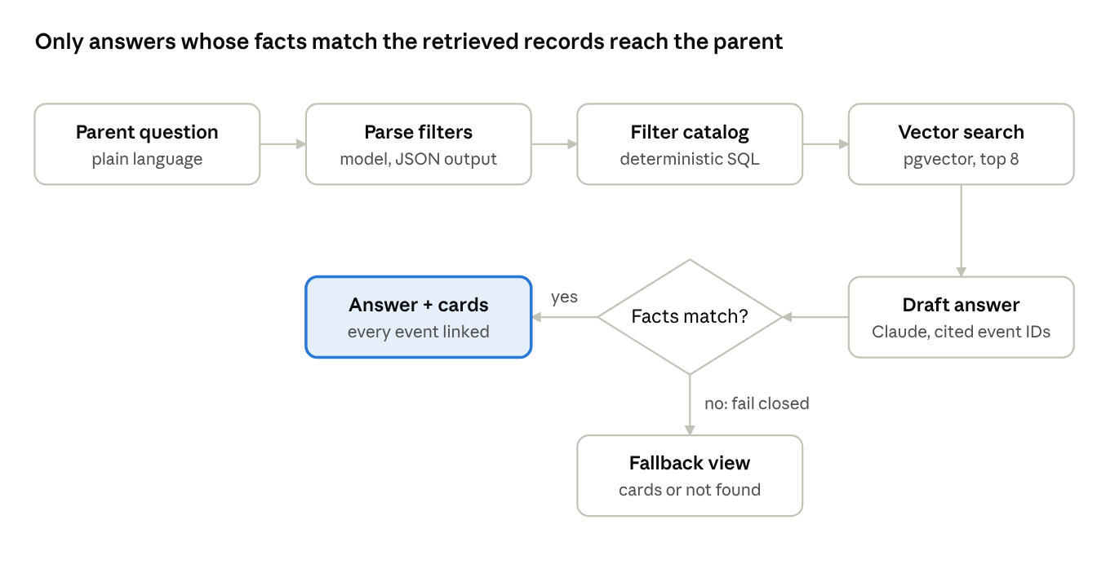
Ask Open Eventz request flow · 6 steps, 1 check
- Parse filters. The model turns the question into structured filters (date range, city, max cost, age, indoor or outdoor) plus the free-text intent, as JSON. Anything it can't parse is left empty rather than guessed.
- Filter the catalog. A SQL query on the existing structured fields narrows to events that meet the hard constraints. Dates and prices are never left to similarity search.
- Vector search. Within that set, pgvector in Supabase ranks events by similarity to the intent ("trains", "rainy day") and returns the top 8. Embeddings are written by the nightly ingest for new and changed events, and deleted with cancelled events.
- Draft the answer. Claude Sonnet gets only those 8 records and returns JSON: the answer text plus the event IDs it used. The prompt forbids stating any fact not in a record.
- Check before showing. Code verifies that every cited ID was retrieved and that every price, age, and date in the text matches its record. Any mismatch fails closed to the fallback view.
- Show the result. The answer with linked cards, or the cards alone, or a one-line "not found" with the closest filter view.

Evaluation plan
Ask Open Eventz ships only when a DeepEval suite passes the gates in the metrics table, and the suite runs in CI on every change to a prompt, the model ID, the retrieval settings, or the check code. It sits beside the existing golden set, which keeps its own zero-tolerance gate on free mislabels.
Eval set (built before measuring)
- About 60 hand-written questions, labeled blind with the event IDs a careful person would cite
- Mix: ~30 answerable, ~15 with no matching event (the refusal cases), ~10 tricky on price or age ("free" events that need a ticket, all-ages events with adult content), ~5 off-topic
- Pinned to a frozen catalog snapshot so results don't drift with the nightly ingest
DeepEval metrics
Metric | What it catches
Faithfulness | Claims in the answer that no retrieved record supports
Contextual recall | Events a person would cite that retrieval missed
Contextual precision | Irrelevant events ranked above relevant ones
Answer relevancy | Answers that drift from the question
G-Eval (custom) | Refusal quality: says "not found" plainly, offers the closest filter view, invents nothing
Custom deterministic tests (pytest, alongside DeepEval)
- Every cited ID is in the retrieved set
- Any price, age, or date in the text equals its record
- No-match questions return the fallback view, never a drafted answer
Reading results
- Gate on the errors that matter (unsupported facts, wrong cost or age, missed refusals), not one blended score
- Read the judge's written reasons on every failure, not just the scores; the classifier work showed that's where roadmap findings come from
- Spot-check 10 judge verdicts by hand each run to confirm the LLM judge agrees with a person before trusting its scores

Guardrails and responsible AI
Every guardrail fails closed: when in doubt, the parent sees event cards or "not found", never an unchecked answer. Each one is added to the governance audit with what it covers and the risk accepted.
Risk | Guardrail | Fails to
Invented event, price, or age | Post-generation fact check against retrieved records | Cards only
Stale or cancelled event in an answer | Embeddings deleted with the cancellation purge; retrieval reads only live events | Not shown
Adults-only event for a kids' query | Same age screening as the list view, applied before retrieval | Excluded
Prompt injection inside event text | Event descriptions passed as data, answer limited to JSON schema, cited IDs checked | Cards only
Personal data in questions | Questions logged without IP or user ID; 30-day retention | Nothing identifying stored
Runaway cost | Per-answer token cap and a daily spend ceiling on model calls | Filter view
Over-trust | Disclosure line under every answer; inferred values keep their confidence label | Parent verifies on the card
Control documentation: a short model card (model, prompts by version, eval results, known gaps) committed with each release, and a decision log entry for every threshold set.

Backlog and delivery plan
Five stories, in order, roughly a weekend of build plus an evening of eval tuning. The eval set comes before the feature so the ship gate is fixed before any result is seen.
- ☐ Story 1: Eval set first. Write and blind-label ~60 questions against a frozen catalog snapshot; commit the ship gates to the repo. Done when the set and the gates are merged.
- ☐ Story 2: Embeddings in the ingest. Enable pgvector in Supabase; the nightly ingest embeds new and changed events and deletes embeddings on cancellation. Done when every live event has one embedding and a cancelled test event leaves none.
- ☐ Story 3: Retrieval. Filter parsing to JSON, SQL hard filters, vector ranking to top 8. Done when contextual recall ≥ 0.85 on the eval set.
- ☐ Story 4: Grounded answer and fact check. Answer generation with cited IDs, the post-generation check, and the fallback view. Done when faithfulness ≥ 0.90, zero wrong cost or age, and 100% correct refusals.
- ☐ Story 5: Ship. UI above the event list, disclosure line, GA4 events for question asked, answer shown, fallback shown, and card clicked; DeepEval suite added to CI; model card and decision log entries. Done when CI blocks a deliberately broken prompt and the dashboard shows the new events.
Open question: hold the feature behind a flag until real parents arrive, or turn it on at launch?

Resume bullet and interview points
Do not submit any of this until Story 5 is merged and live. It goes in as the seventh Open Eventz bullet on the Deloitte resume, and the Skills line "RAG-based knowledge assistants over Confluence and Jira" becomes "Retrieval-augmented generation (pgvector), DeepEval".
Bullet, once live (no figures):
Launched Ask Open Eventz, retrieval-augmented Q&A that answers parents only from catalog records: hard filters in SQL, vector search for intent, cited event IDs, and a fact check that fails closed to event cards. Gated release on a DeepEval suite in CI, with faithfulness, recall, and refusal thresholds set before measuring.
Bullet, once the eval run is in (fill from the real report):
… Shipped at [faithfulness score] faithfulness with zero wrong prices or ages across [N] blind-labeled questions.
Interview points
- Why SQL before vectors: dates and prices are hard constraints, and similarity search can't be trusted with them
- Why the eval set came first: the ship gate was written before any result was seen, so a weak build couldn't talk its way past it
- What the LLM judge can't be trusted on, and how the hand spot-checks keep it honest
- What failed in the first eval run and what changed because of it (fill in after Story 4)

